

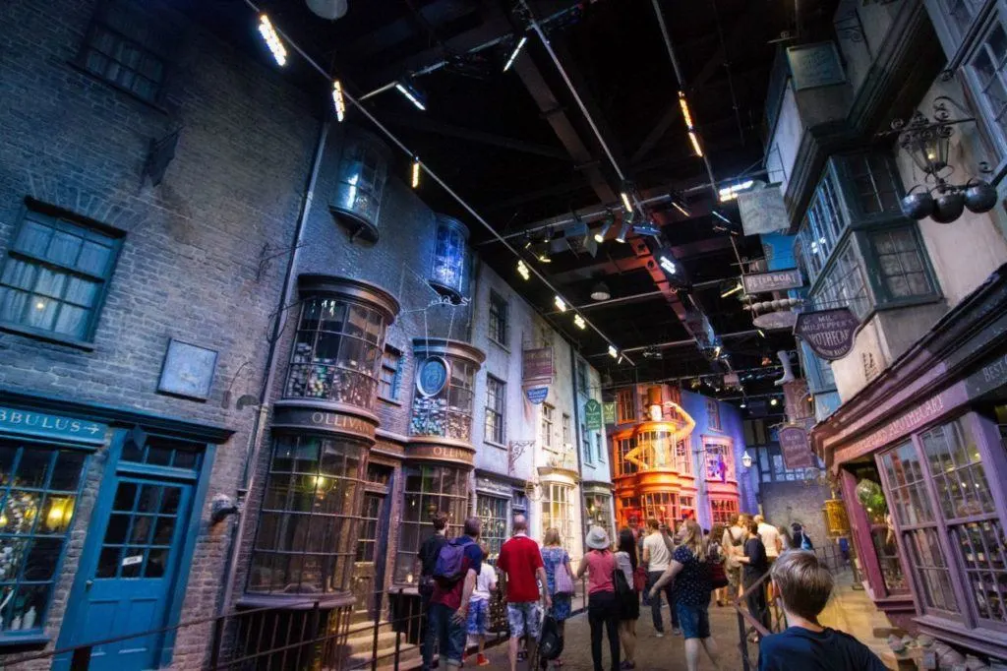

ADVANCED DESIGN SKILLS
ASSIGNMENT 1:
“Lights, Camera, Build”

Prepared by Lana Stockton
School of Creative Arts

The University of Hertfordshire has a non‐exclusive license for an indefinite period to copy and communicate all works submitted within this course. Your work may be communicated within a website, lecture or within marketing materials generated by the University. All work will be correctly attributed to you.

Copyright material contained within this document has been used within the provision of the Copyright Act 1968, or where indicated, with permission of the copyright owner.

This work is copyright. Apart from any use permitted under the Copyright Act 1968, no part may be reproduced by any process without the prior written permission of University of Hertfordshire, Hatfield, Hertfordshire, AL10 9AB.

© University of Hertfordshire
This Module Brief and the associated course notes have been prepared by Lana Stockton, 2024.
Cover Image: https://www.reflectionsenroute.com/harry-potters-real-world-the-backstage-reveals-all/

PROJECT KEY DATES

DATE | TIME | ACTIVITIES | ASSESSMENT WEIGHTING | Learning Outcomes
9/12/24 | Before 23:59 | Project 1  Model AB145 drop off  Canvas submission | 50% | IS1, IS4, PTS2, PTS3, PTS4
13/01/25 | - | You will receive summative feedback + marks via Canvas. |  | -
24/03/25  7/04/25 | Crit at timeslot  Before 23:59 | Final INTERVIEW  Project 2  Canvas submission | 50% | KU2, IS1, IS4, PTS2, PTS4
26/05/25 | - | You will receive summative feedback + marks via Canvas. | 50% | -
20/06/25 | Before 15:00 | REF/ DEF  Canvas submission | Refer to above. | Refer to above.
07/07/25 | - | You will receive REF DEF feedback + mark via Canvas | 100% | -

INTRODUCTION
Introduction Date: Monday 30th September 2024
Due Date: Monday 9th December 2024

Assessment Weighting: 50% of Course Mark (Summative)
Submission Location: Canvas
Time: Submission: 23:59

ASSIGNMENT BRIEF
Assignment 1 requires the students to work in groups of 3 or 4, to design a Factual Entertainment TV set. This is a live project in collaboration with the UH Film Department; only one set will be chosen to be built, so you will need to make it somewhat universal. This is a competition; Ken Kirby (Senior Lecturer in Docuseries) and Paul Roberts (Senior Technician) will be choosing the winner. The winning set will then be built at the end of Semester B for filming, but your participation is only for Semester A.
You will be allocated one of the following design themes as your core theme;
- Business, Journalistic and Sports
- Lifestyle, Competitions and Personal Stories
Generally, the space in which you will be creating will need to:
- Have a seating area for primary interactions & discussions
- Entry for guests
- Breakout area/secondary space for additional interactions
- Additional flexible spaces for other on-screen interactions (e.g. musicians, acts, catwalks, monitor analysis, interviews... )
To make the sets universal (as several different tv shows will need to be extracted from your singular set), you will ideally show how subtle changes in lighting and/or set rearrangement can alter the core aesthetic. Currently, the setup is created by the film technician, who has skilfully used the limited resources to dress the set, along with creative lighting to create the distinctive designs. As specialists in spatial design, you will come up with a phenomenal design which will not consider budgetary restrictions. The reality is your design will be reduced/compressed to work with what the university can create.
Do not let this hinder your creativity!
It is easy to reduce a spectacular design, so don’t start mediocre.

SUBMISSION DETAILS (minimum)
Part I: Modelling
Assignment 1 (Part I) requires your collaborative team to: model the design in 3D.
The submission items include:
A. 3D model and any 2D drawing files (original file)

Part II: Technical Details & Visualisation
Assignment 1 (Part II) requires your collaborative team to: produce a set of drawings illustrating the key elements that need to be constructed and highlighted. ALL drawings need to be properly cross referenced in annotations and notes.
The submission items include:
B. Renders/visualisations of space(s) and alternative space aesthetics
C. Storyboard: illustrate the framing of shots in those static areas and flexible spaces to assist the cinematographer
D. Technical plans: Floor plan, lighting plan, electrical plan, floor and wall finishes plan
E. Elevations and/or sections
F. Any specific bespoke design detailing relevant to your core design
G. Specification

Part III: Client presentation
Assignment 1 (Part III) requires your collaborative team to: assemble all modelling, technical details and visualisations into a short client presentation. DO NOT include precedents, or design development. This is a FINAL collection of what your group has created, showcasing why they should choose your team's design.
The submission items include:
H. The project brief, site & project analysis, and final design elements – one single PDF

Part IV: Lecture Notes
I. Submit all group members in-class lecture notes (photocopied if handwritten) in a separate PDF.

As final year students, this is your chance to illustrate your strengths as a designer and breadth of knowledge showcasing your flexibility to work on diverse projects. The software you use is your choice, and chance to develop your digital skills to the maximum before entering the industry.

TIMETABLE
“There are 360 degree’s, so why stick to one?” Zaha Hadid
Calendar subject to change. An up-to-date IAD calendar is on:
IAD Timetable

Note: Please note the teaching schedule may change according to the academic progress of the student cohort.

DECLARATION
By submitting you are declaring that your submission is entirely your own work. If you have cited from other sources or in any way included material that was not produced by yourself, those sources must be acknowledged. Failure to acknowledge where work is not your own may result in an allegation of academic misconduct. For more information, see 'Assessment Offences and Academic Misconduct' on Ask Herts, together with the following guidance from Library SkillUP"
'Referencing: Why do it? Introduction'
'Academic Integrity'
'Why bother to acknowledge the work of others?'
'Test your knowledge: Understanding plagiarism'

THIRD-PARTY ASSETS
If it is permissible for students to use any third-party assets in their submission following:
a) Any images, quotations or third-party assets are acceptable given;
b) Any references (a) must be acknowledged in the submission through Harvard referencing.

ETHICS
The Ethics Committee must approve all coursework that involves ‘human participants’ (such as interviews, questionnaires or surveys, even where these are conducted among family/friends). Applications should be made to the committee at least two weeks before the start of a project. Approved applications will receive a protocol number and this should be included as part of the module submission. If students undertake work that involves human subjects without the prior approval of the Ethics Committee they may incur an academic penalty. Guidance on how to make an application is contained in the School's Student Handbook here.

RISK ASSESSMENT
A risk assessment is not required for this assignment

HOW TO SUBMIT YOUR WORK
Students are to submit the submission requirements online on Canvas under assignments.
The physical model will be submitted in person to the tutors on the last week of teaching of the semester. All models must be handed in by the student who created it, and signed for.

Grades Descriptors and Reference Grades:
(Undergraduate reference scale to assist coarse-grained marking of individual pieces of work)
- Excellent / Outstanding Work: (First Class equivalent at L5 and L6): 95*, 85
- Very Good Work: (First Class equivalent at L5 and L6): 77, 72
- Good Work: (Upper Second Class equivalent at L5 and L6): 68, 65, 62
- Clear Pass: (Lower Second Class equivalent at L5 and L6): 58, 55, 52
- Marginal Pass: (Third Class equivalent at L5 and L6): 48, 45, 42
- Marginal Fail: (LO’s not evidenced): 38 (F), 35 (F), 32 (F)
- Clear Fail: (LO’s not evidenced): 25 (F)
- Little or Nothing of Merit: (LO’s not evidenced): 10 (F)
*Reference Grades above 90, should be awarded for work of truly exceptional quality and used very sparingly.

Engagement by the student in all aspects of Teaching and Learning and Assessment are essential to ensure successful completion of the module, students with an OVERALL Module Grade below 20% will not be offered the opportunity for a referral and will be required to repeat the module if permitted.

Penalties for Late Submission:
- For first-sitting or deferred coursework, for each day (or working day for hard copy submission only) for up to five days after the published deadline, coursework submitted late (including deferred coursework, but with the exception of referred coursework), will have the numeric grade reduced by 10 grade points until or unless the numeric grade reaches or is 40.
- Referred coursework submitted after the published deadline should be awarded a grade of zero unless an extension has been granted.

Referrals: For students who are referred due to failure on first-sitting of one or more elements of assessment, only the assessment elements which have been failed and then passed at referral will be capped to 40. The module grade overall will not be capped.

Re-enrolment: Following re-enrolment on any module, the grades awarded shall be those actually achieved in the assessment. Grades will not be capped except where there are penalties for other circumstances (such as late submission).

ACADEMIC INTEGRITY

Academic integrity, honesty, and a respect for knowledge, truth and ethical practices are fundamental to the business of the University. These principles are at the core of all academic endeavours in teaching, learning and research. Dishonest practices contravene academic values, compromise the integrity of research and devalue the quality of learning.

By submitting you are declaring that your submission is entirely your own work. If you have cited from other sources or in any way included material that was not produced by yourself, those sources must be acknowledged. Failure to acknowledge where work is not your own may result in an allegation of academic misconduct. For more information, see:

https://ask.herts.ac.uk/assessment-offences-and-academic-misconduct

Module Aim(s)
The aims of this module are to enable students to...
- Understand at an advanced level, the structural design, constructional and engineering problems associated with building design.
- Gain advanced knowledge of the industries, organisations, regulations and procedures involved in translating design concepts into buildings and integrating plans into overall planning.
- Have advanced design skills to meet building users' requirements within the constraints imposed by cost factors and building regulations.
- Have a comprehensive understanding of connections between social, cultural, economic and technological contexts and demonstrate the appropriate and creative application of that knowledge in the development of a project brief.

Intended Learning Outcomes
Knowledge and Understanding
- Successful students will typically...
- Have knowledge and understanding of complex issues surrounding legislative knowledge relevant to practice, cost factors, building regulations and legal aspects of projects. (KU2)

Intellectual, Practical and Transferable Skills
- Successful students will typically...
- Demonstrate analytical and creative skills to the application of comprehensive design solutions in response to a design brief. (IS1)
- Analyse problems that synthesise appropriate solutions appropriate to the discipline. (IS4)
- Respond to complex challenges, through the development and realisation of realistic design proposals. (PTS2)
- Work effectively as part of a team. (PTS3)
- Demonstrate an advanced ability to conceptualise and convey complex ideas through visual representation in both 2D and 3D formats. (PTS4)

